Year 10 forces – Friction
For each activity, explain whether friction helps or decreases the performance of that activity.
Then explain how the person increases or decreases friction.
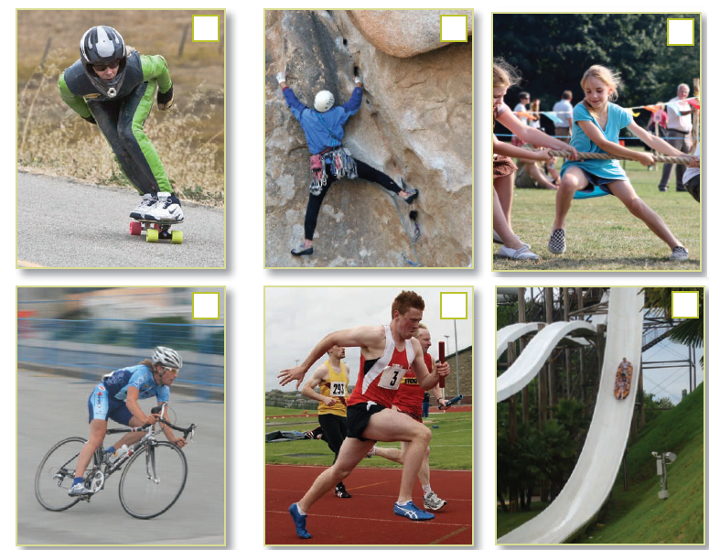

Activity | Friction is good or bad | Explain how friction is increased or decreased to improve performance
Rollerskating
Rock climbing
Tug of war
Cycling
Running
Sledding/tobogganing

